
MUNDY ROAD ELEMENTARY

SCHOOL DISTRICT NO. 43 (COQUITLAM)
2200 Austin Avenue, Coquitlam, B.C. V3K 3S1
Telephone: (604) 936-4271 Fax: (604) 936-9627
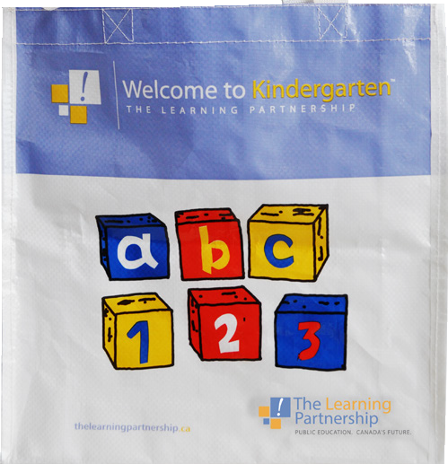







Dear Parents/Guardians of our September 2015 Kindergarten Class,
You and your kindergarten child are invited to come to our “Welcome to Kindergarten” event at Mundy Road on THURSDAY, May 21th, from 1:30 to 2:30. This event is meant to provide you and your child with some resources and positive experiences to bring with you as you get ready for the Kindergarten year. Students will have a chance to get a taste of school life, meet some of the school staff, participate in play activities in the gym and receive a Welcome to Kindergarten bag with a book and activities. ***As this is an event for Kindergarten students and their parent/guardian, we respectfully request that siblings do not attend.
On THURSDAY, May 28, from 6:00- 7:00 we will be having an Evening Parent Orientation Session. This session will give you an opportunity to meet other kindergarten parents, the principal, kindergarten teachers and other representatives from our community. There will be a short presentation followed by an opportunity to ask lots of questions.

We will be discussing: full day kindergarten, play based curriculum, school routines, protocols for communication, information about our school community.

When parents have the opportunity to take an active role in their children’s education, children have a greater prospect for success. Parents learn valuable ways to help their children by reinforcing skills taught at school. Teachers and school staff have an opportunity to get to know the new kindergarten students and their families.

We look forward to seeing everyone!
Mrs. McGovern, Mrs. Warner, Mr. Samson and Mr. Wright

***Please RSVP to Bonny Gibson, the school secretary (at bogibson@sd43.bc.ca), so that the school can get an idea of how many people we should expect at each event. When RSVPing please specify the following:

____ yes I will be attending the “Welcome to Kindergarten” event at Mundy Road on THURSDAY, May 21th, from 1:30 to 2:30 with my Kindergarten child.

____ no I will not be attending the “Welcome to Kindergarten” event at Mundy Road on THURSDAY, May 21th, from 1:30 to 2:30 with my Kindergarten child.

____ yes I will be attending the Evening Parent Orientation Session on THURSDAY, May 28, from 6:00- 7:00.
____ no I will not be attending the Evening Parent Orientation Session on THURSDAY, May 28, from 6:00- 7:00.

